Technical Datasheet of WIN-4G-GW-16UI8UO-ETH Module (Modbus TCP/IP)
1. Overview
The Universal Input (UI) and Universal Output (UO) board support communication exclusively over Modbus TCP/IP, enabling seamless control and monitoring of inputs/outputs. The board provide configurable input and output selection via TCP/IP web pages, ensuring flexibility across various applications. The module acts as an input/output device between the Modbus TCP/IP Network and the Gateway.
Digital IO module is sturdy, low power usage and easy to use.
Through the 4G network, device data can be transmitted using the MQTT protocol, allowing real-time monitoring and integration with cloud platforms or IoT systems.

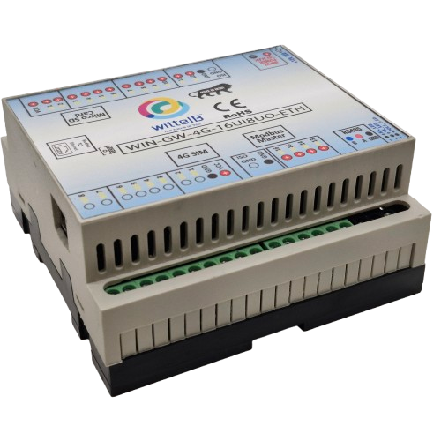
The IO modules are mounted on DIN rail mountable casing and with exposed connectors and LED indicators.

Specifications
Category | UIUO Module
Input Type | Analog Input (10V)  Analog Input (5V)  Digital Input  NTC Sensor Input.  (Configurable via TCP/IP web page)
Output Types | Analog Output (AO),  Digital Output (DO).  (configurable via TCP/IP web pages)
Connectors | Single port handling multiple input/output types

General –

Dimensions 110 mm L x 110 mm B x 50 mm H
Power Input Power – 9 – 24 V DC or 24 V AC/DC
Typical – 24V DC @ 700mA
Operating Temperature 0 – 60° C (32 ~ 140°F)
Storage Temperature -20 - 70° C (-4 ~ 158°F)
Storage Humidity 5 ~ 95 % RH, non – Condensing
Certifications 

UI (Universal Inputs) –

Digital Input channels 16
Sense Voltage 3.3 – 12 VDC (Depends on the selected type of Input)
Digital Sensing Logic Logic ‘0’ = <1 VDC, Logic ‘1’ = >3.3 VDC
Isolation Optically isolated
Response Time 2 msec, Max 6 msec

Analog Input channels 16
Input Signal 0 – 5VDC / 0 – 10VDC / NTC (Web page selectable)
Accuracy ± 2% Full scale
Input Resolution 10 bits
Isolation Optically Isolated
External Loop Voltage + 15 VDC min
AI input impedance 120Ω

UO (Universal Outputs) –

Digital Output channels 8
Output Type P-Channel MOSFET
Channel Voltage 12 VDC
Channel Current 20A
Channel Power 240 W (max)
Operating Time 2.8ns.
Turn Off delay Time 33.5ns.
Operating Temperature -55℃~+150℃

Analog Output channels 8
Analog Resolution 10 bits (0 to 10VDC)
Accuracy ± 2% Full scale
Isolation Optically Isolated
Conversion Time 15 msec

Additional Features: -
Input power reverse polarity safety
ESD Safety IEC 61000-4-2, ± 30KV contact, ± 30KV air

Configuration Of UIUO module
The UI/UO module supports flexible I/O configuration.
Each of the 16 UI (Universal Input) ports can be independently configured as Analog Input, NTC Sensor Input, Digital Input. Similarly, each of the 8 UO (Universal Output) ports can be independently configured as, Analog Output, Digital Output
All the configuration can be done through Web page hosted at the default IP address (i.e. 192.168.1.177) or at the changed IP address.
The following are step by step guide for configuration:
- Connect the Module to +24VDC POWER SUPPLY.
- Connect the Board to the PC via an Ethernet Cable.
- 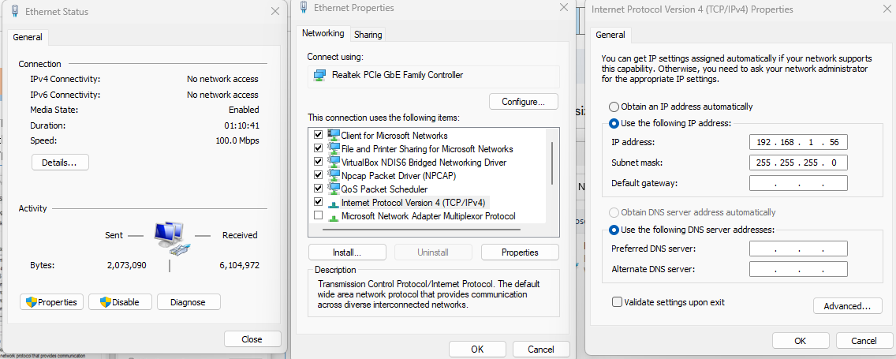Use the default setting for PC as TCP/IPv4 (i.e., Address -192.168.1.56).

- 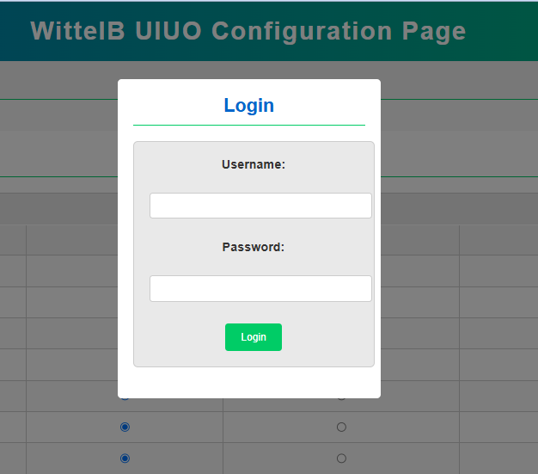Now, open web browser and type 192.168.1.177 (default IP address) and Press ‘Enter’. A login page will appear as shown below.

- Default Login Credentials are :
Username: admin
Password: admin

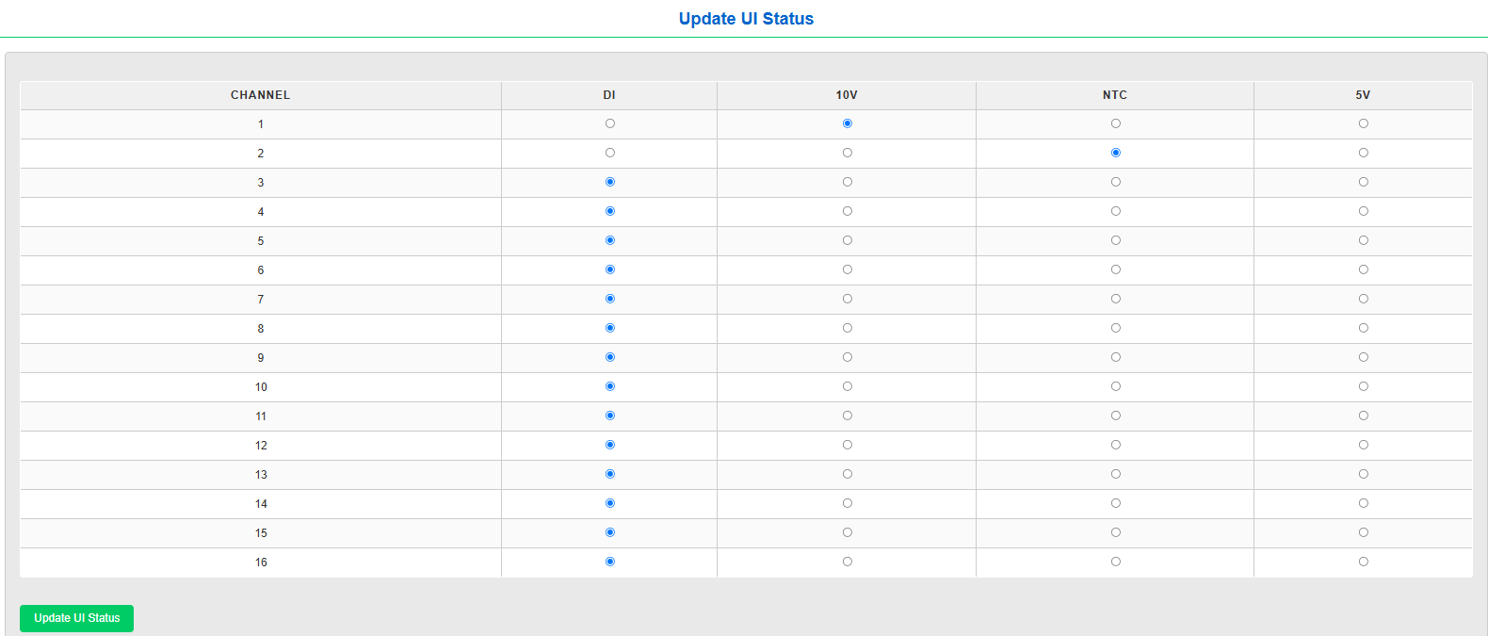
- After successful login, The UIUO Configuration page will be visible. It has multiple tables. The first named as ‘Update UI Status’ and ‘Update UO Status’ which have selectable radio button for doing the configuration of respective channels as shown below.

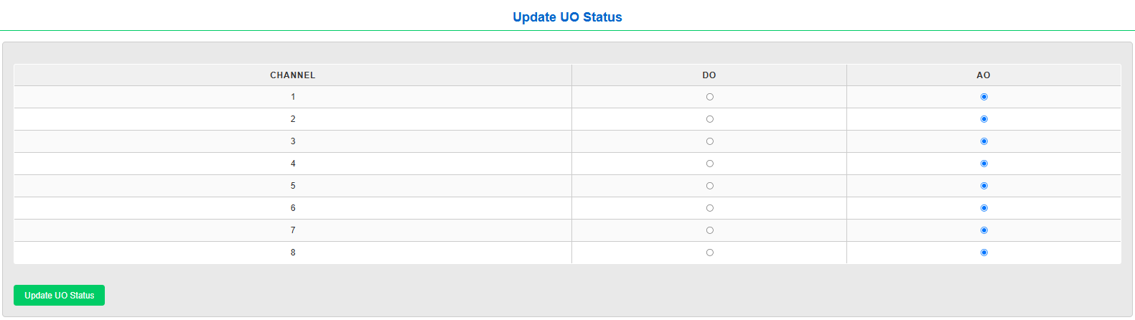
- For example, to set Channel 1 of UI as NTC Sensor input, the radio button in front of Channel 1 must be selected as NTC and then “Update UI Status” button need to be pressed. This will make the Channel 1 of UI port as NTC sensor input port.

Note: Always restart the device/refresh the page after doing configuration for UI/UO Status, then only changes in configuration will take place.
- 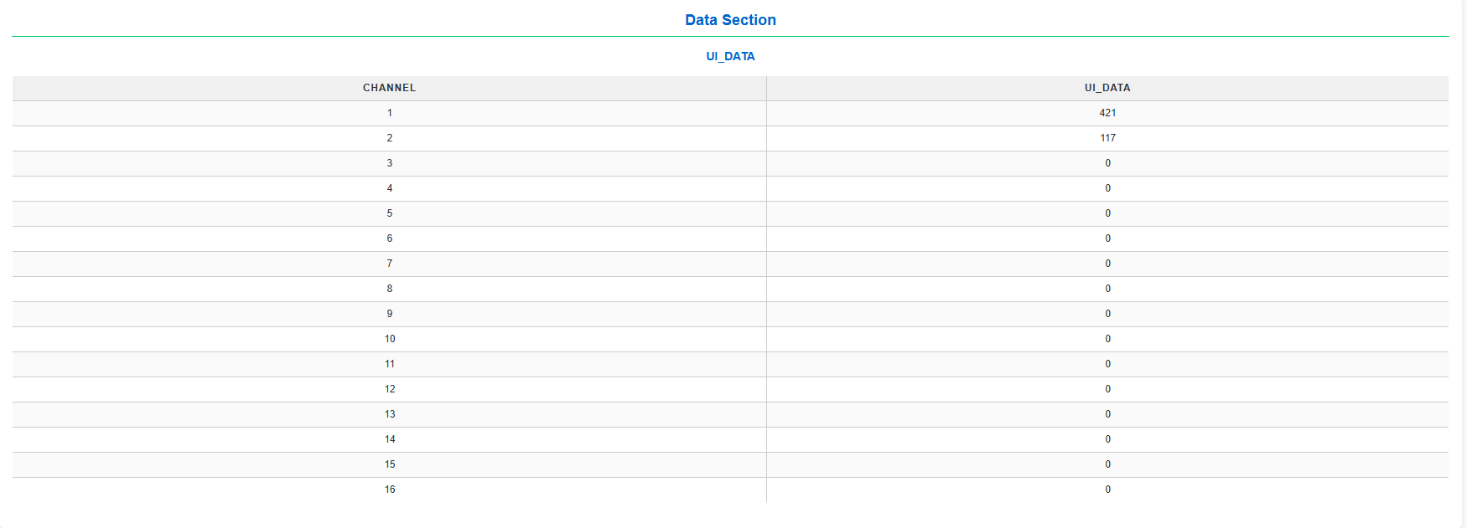The third table “UI_DATA” is for viewing the UI port data locally on the web page.

- User can select all the desired configuration at once and then press the Update button for UI or UO to update the Port status in the module.

- User can change the IP and Mac Address for the TCP from the tab “MODBUS TCP CONFIGURATION” in the web page and press the “Save Configuration” button and restart the device to set the new IP, as shown below.

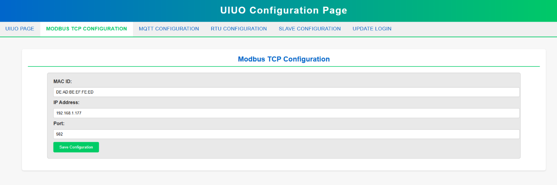

Note: To reset the IP address to default IP, the user need to press and hold the reset button located near the Ethernet port for 5 seconds.

- On the tab “UPDATE LOGIN” page, the user can change the Username and Password, to enhance the security of UIUO module, as show below.
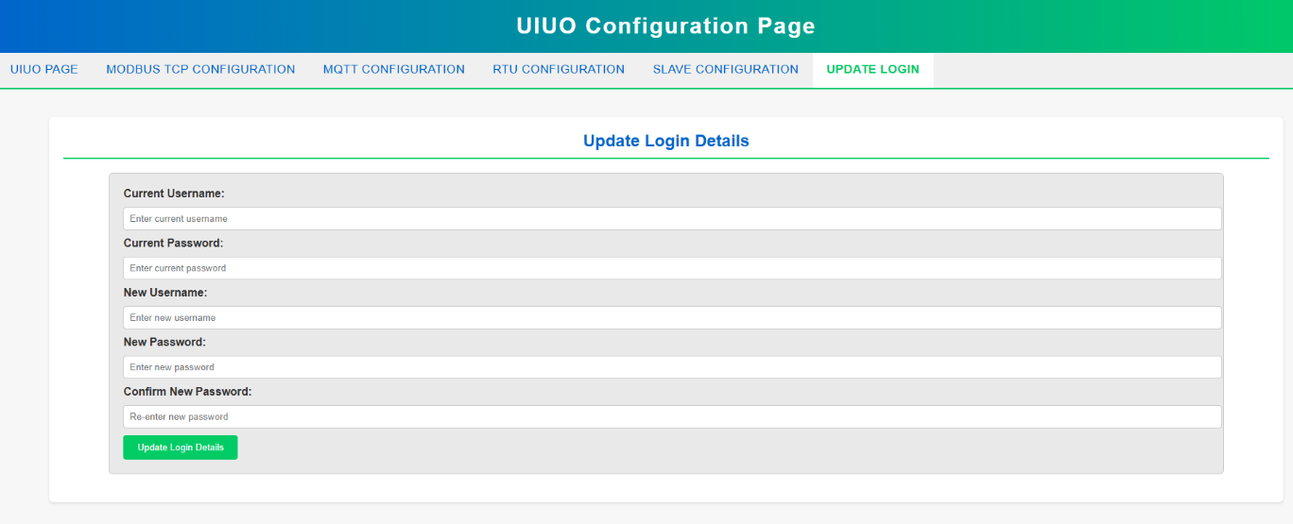

- After all the configuration, User can now connect the UIUO module to Modbus TCP master at the set IP address or default IP address (192.168.1.177).

- On the tab “MQTT CONFIGURATION” page, the user can give the MQTT Credentials to get the data on cloud, and select the option to get data on cloud through 4G/Ethernet, then click update MQTT details.

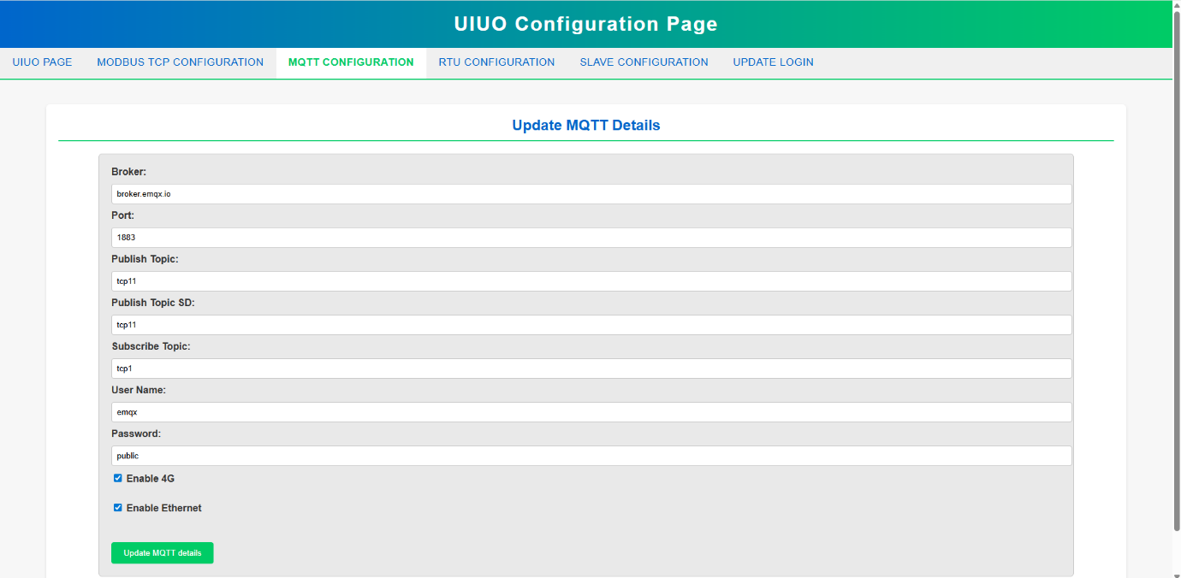

- On the tab “RTU CONFIGURATION” page, user can give the RTU Configuration for slave - Baudrate, Data bit, Parity, Stop bit, then submit the configuration.

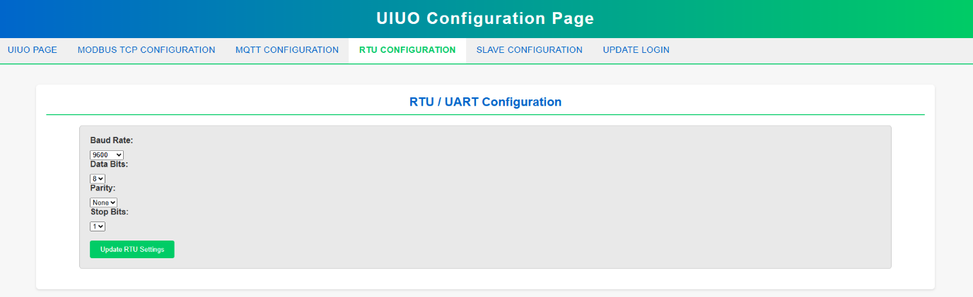

- On the tab “SLAVE CONFIGURATION” page, user can give the Slave Configuration as slave ID, Start Register, End Register, Quantity, Function Code, then submit the configuration.

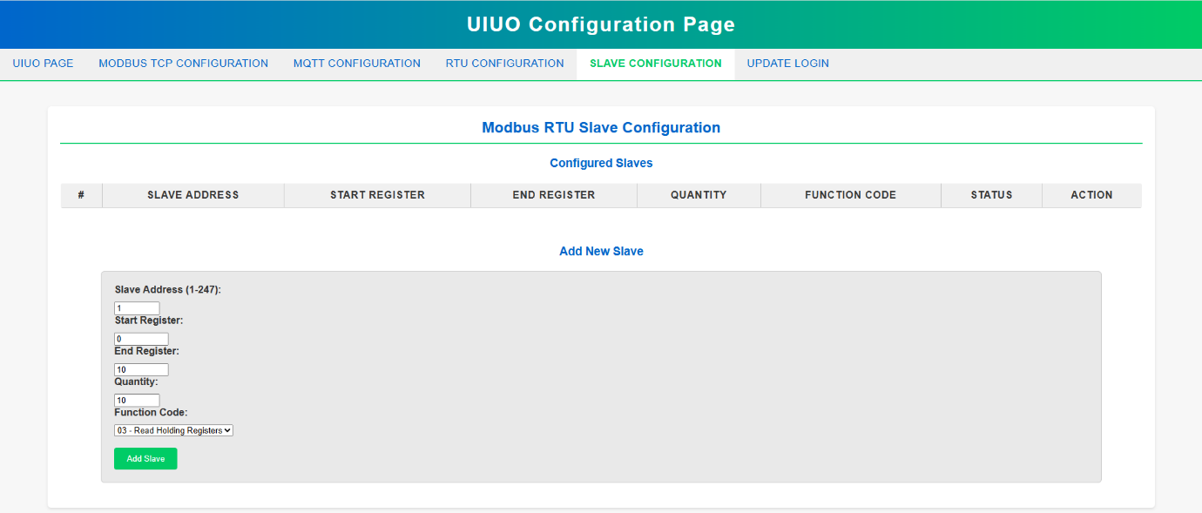

- Here we have shown a connecting with Modbus Poll software for demonstration in the below images.

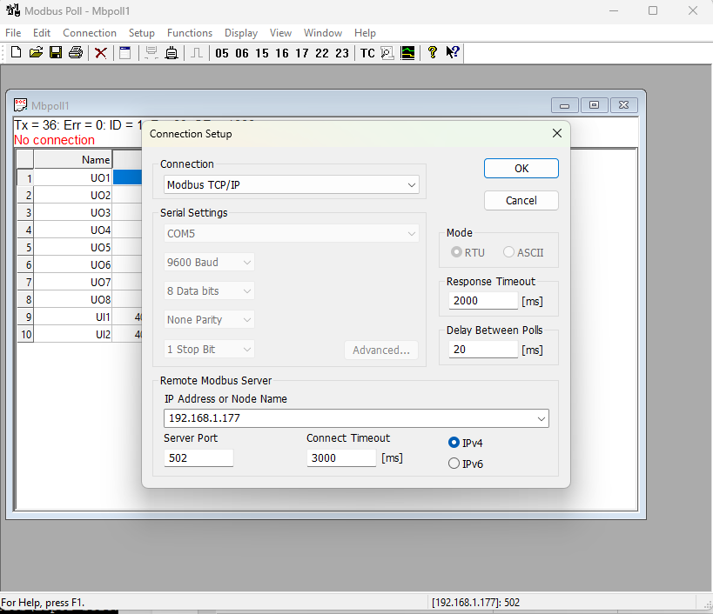
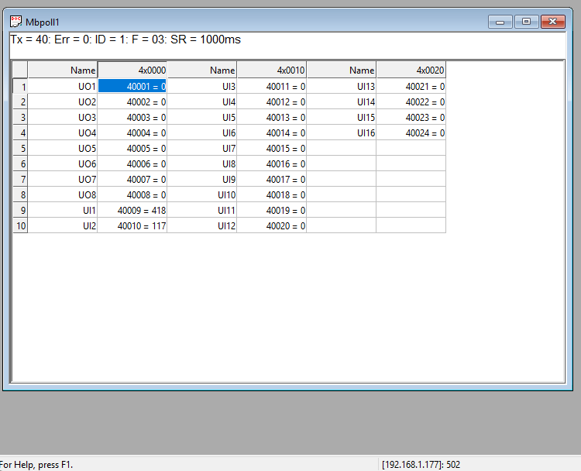

- The data of UI port can be fetched from the mentioned Modbus register in the table below, irrespective of DI, AI, NTC, selection. The Desired Inputs are as follows:
INPUT TYPE | Input Value
DI | 0 V(0) , 12VDC (1)
AI(5V) | 0 to 5VDC (0-1023)
AI(10V) | 0 to 10VDC (0-1023)
NTC | NTC sensor(Temperature in °C)

- Similarly, the data of the UO port can be set in the same register as mentioned in the table below. For DO, It should be sent 0 or 1 (12VDC). And for AO a 10-bit resolution value must be sent (i.e. from 0 to 1023) to set output of 0 to 10VDC.

OUTPUT Type | Output Value
DO | 0 (0V) , 1 (12VDC)
AO | 0 to 10VDC (0-1023)

MODBUS COILS TABLE FOR UIUO PORTS:-
ID | Function  Description | Register  Description | Modbus Function Code | Data  Type
1 | UO 1 (DO) | 00001 | 0x05,0x15,0x01 | Boolean
2 | UO 2 ( DO ) | 00002 | 0x05,0x15,0x01 | Boolean
3 | UO 3 ( DO ) | 00003 | 0x05,0x15,0x01 | Boolean
4 | UO 4 ( DO ) | 00004 | 0x05,0x15,0x01 | Boolean
5 | UO 5 ( DO ) | 00005 | 0x05,0x15,0x01 | Boolean
6 | UO 6 ( DO ) | 00006 | 0x05,0x15,0x01 | Boolean
7 | UO 7 ( DO ) | 00007 | 0x05,0x15,0x01 | Boolean
8 | UO 8 ( DO ) | 00008 | 0x05,0x15,0x01 | Boolean
9 | UI 1 (DI) | 00009 | 0x01 | Boolean
10 | UI 2 (DI) | 00010 | 0x01 | Boolean
11 | UI 3 (DI) | 00011 | 0x01 | Boolean
12 | UI 4 (DI) | 00012 | 0x01 | Boolean
13 | UI 5 (DI) | 00013 | 0x01 | Boolean
14 | UI 6 (DI) | 00014 | 0x01 | Boolean
15 | UI 7 (DI) | 00015 | 0x01 | Boolean
16 | UI 8 (DI) | 00016 | 0x01 | Boolean
17 | UI 9 (DI) | 00017 | 0x01 | Boolean
18 | UI 10 (DI) | 00018 | 0x01 | Boolean
19 | UI 11 (DI) | 00019 | 0x01 | Boolean
20 | UI 12 (DI) | 00020 | 0x01 | Boolean
21 | UI 13 (DI) | 00021 | 0x01 | Boolean
22 | UI 14 (DI) | 00022 | 0x01 | Boolean
23 | UI 15 (DI) | 00023 | 0x01 | Boolean
24 | UI 16 (DI) | 00024 | 0x01 | Boolean

MODBUS REGISTERS TABLE FOR UIUO PORTS:-
1 | UO 1 (AO) | 40001 | 0X03 | 16 Bit Unsigned int
2 | UO 2 (AO) | 40002 | 0X03 | 16 Bit Unsigned int
3 | UO 3 (AO) | 40003 | 0X03 | 16 Bit Unsigned int
4 | UO 4 (AO) | 40004 | 0X03 | 16 Bit Unsigned int
5 | UO 5 (AO) | 40005 | 0X03 | 16 Bit Unsigned int
6 | UO 6 (AO) | 40006 | 0X03 | 16 Bit Unsigned int
7 | UO 7 (AO) | 40007 | 0X03 | 16 Bit Unsigned int
9 | UI 1 (AI,NTC) | 40009 | 0x03 | 16 Bit Unsigned int
10 | UI 2 (AI,NTC) | 40010 | 0x03 | 16 Bit Unsigned int
11 | UI 3 (AI,NTC) | 40011 | 0x03 | 16 Bit Unsigned int
12 | UI 4 (AI,NTC) | 40012 | 0x03 | 16 Bit Unsigned int
13 | UI 5 (AI,NTC) | 40013 | 0X03 | 16 Bit Unsigned int
14 | UI 6 (AI,NTC) | 40014 | 0X03 | 16 Bit Unsigned int
15 | UI 7 (AI,NTC) | 40015 | 0X03 | 16 Bit Unsigned int
16 | UI 8 (AI,NTC) | 40016 | 0X03 | 16 Bit Unsigned int

Wiring Diagram:-
The Port number and Sequence of UI and UO are as mentioned in the wiring diagrams shown below. Also the position of default reset button is as shown in the diagram.

1-12 UI

GND
12v Ref
Input
9-24 VDC
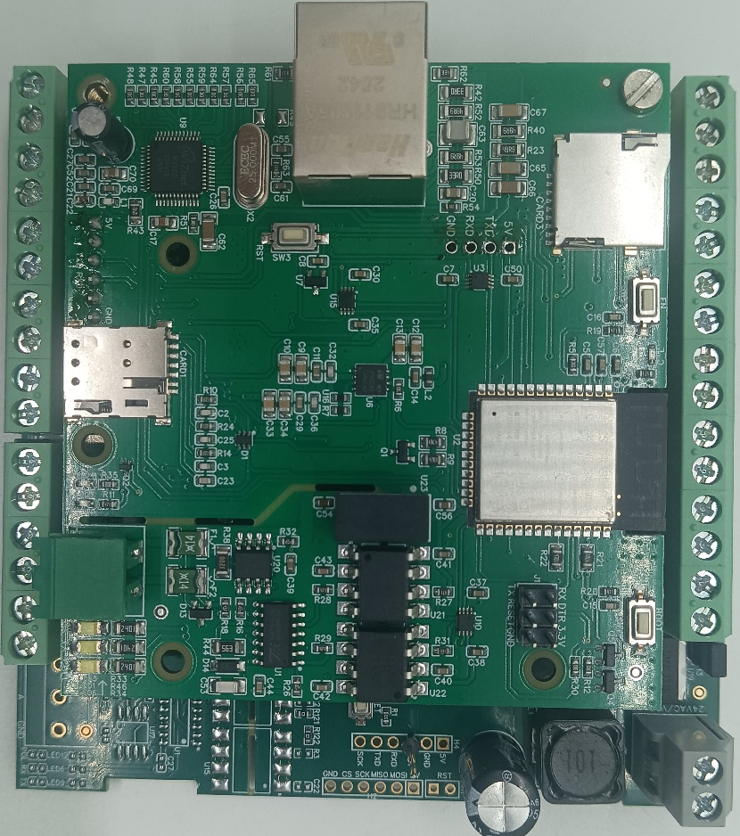
SIM-Card
SD-Card
Modbus
RS485
Reset
Ethernet
8-1 UO

16-13 UI

GND

Contact us: -
Augmatic Technologies Pvt. Ltd.,
Plot no 6, Shah Industrial Estate II,
Kotambi,
Vadodara – 391510.
Email – Sales@wittelb.com

